REQUEST FOR PROPOSAL
Environmental Remediation Services
Head Start Operation Center,
1433 Bacharach Blvd. Atlantic City, NJ
Client: Gateway Community Action Partnership

PROPOSAL PARAMATERS AND GUIDELINES

- Submission Requirements. All proposals must be presented in accordance with the requirements, format, and guidelines described in this Request for Proposal (RFP) document.

- Submission Deadline. Interested entities must submit (3) copies of proposals no later than 4:30 p.m., Friday August 27, 2014. Submittals should be addressed and delivered to:

Edward Bethea, Sr. Vice President/Chief Operating Officer Gateway Community Action Partnership
110 Cohansey Street 08302
(856) 451-6330, Ext. 6655

- Interpretation and Addenda. All questions, requests for interpretation, and comments shall be prepared in writing and submitted to Steven Caputo (scaputo@gatewaycap.org) and Daniel Muller (dtmuller@gatewaycap.org) via email by August 22, 2014. Question and clarification responses will be sent to all parties having submitted questions. All responses will be binding. If a respondent has no questions please state so via email so that responses will be forwarded. Oral and other interpretations will be without legal effect.

OVERVIEW

Gateway Community Action Partnership’s interest is in the vacant building located at 1433 Bacharach Blvd., Atlantic City, NJ Block 293/Lot 1, currently owned by Atlantic County. Gateway believes this site can be turned into an Early Head Start/Head Start center for Atlantic City families. Because this site is situated between AtlantiCare, the library, county and city governmental offices, churches, and a community college, as well as the only supermarket in town, it is an ideal location for our Head Start Program.

REQUEST FOR PROPOSAL

This RFP is issued by Gateway Community Action Partnership (GCAP), a 501 (c) (3) tax exempt nonprofit corporation.

ROLE OF THE Selected Environmental Remediation Contractor

The selected Environmental Remediation Contractor will work closely with GCAP staff on an as-needed basis to provide services for Remediation removal of contaminates form the existing property prior to demolition of the building. A complete environmental report will be provided to the selected contractor once a selection is made from the Bids. The project is located at 1433 Bacharach Boulevard in Atlantic City, New Jersey, Block 293, Lot 1. The project entails complete demolition and new construction. An approximate 62,000 square foot structure is envisioned, with five levels from the ground up. An elevated structure may be needed to satisfy FEMA flood regulations, as the site is three blocks from the shoreline and is in a flood zone.

The entire parcel of land is 15,290 square feet in size. See Appendix A.

Following the RFP submission, the selected Contractor will work closely with GCAP staff, Board, and General Counsel to ensure consistency with overall operating guidelines and requirements of Gateway CAP.

RFP SUBMISSION REQUIREMENTS

Respondent’s submissions must include the following core components, in order to be considered responsive to this solicitation:

- A current client list for related projects
- A fee schedule(s) showing billing rates for the various categories of employees employed by the Contractor and submitted for review and approval. Cost proposals or cost estimates are required at this time. All estimates should be based on Prevailing Wages.
- The Contractors Business Registration & Insurance Certificate must also be current.

CONDITIONS FOR SUBMISSION OF PROPOSAL

All proposals in response to this request must meet the following conditions to be considered:

- 3 copies of the submission: 8.5x11 format; 11x17 fold-outs are permitted
- Breakdown the proposal by the steps of work necessary
- Proposals must be received by the date and time specified; late proposals will be disqualified.
- In order to be considered for selection, applicants must submit a complete proposal. Incomplete proposals may not be considered.
- Proposals must include a Cover Sheet or Letter clearly stating the name of the applicant, address and telephone number of the applicant representative.

The funding award for these services and project shall be made at the sole discretion of the Gateway Community Action Partnership Board of Directors. Gateway Community Action Partnership is under no obligation to select any presented proposals. Funding is subject to all necessary approvals by Federal, State and local agencies and their representatives. GCAP reserves the right to request additional information from all applicants. GCAP reserves the right and anticipates inviting top respondents to engage in an interview process to obtain additional information that will be used during the selection process. GCAP reserves the right to reject any and all proposals submitted, and to negotiate portions thereof.

APPLICATION RANKING CRITERIA.

All submissions shall be initially reviewed to determine if they are responsive to the submission requirements. Those not meeting the minimum requirements set forth herein will be deemed non-responsive, and will not be subject to further review.

The responsive submissions shall be evaluated and ranked in accordance with the scoring criteria, based upon a 25-point system.

5 points – Previous history, working with non-profits and government agencies and your direct experience with Head Start, childcare and commercial projects.

10 points – Overall professional Proposal, experience, proven capacity of the organization and its key personnel and staff

10 points – Timeliness of projected completed date and overall cost estimate

CERTIFICATION FORM NOTE

THIS PAGE MUST BE COMPLETED AND INCLUDED WITH THE SUBMITTAL CERTIFICATION
The undersigned hereby certifies, on behalf of the Respondent named in this Certification (the “Respondent”), that the information provided in this RFP submittal to ISSUER is accurate and complete, and I am duly authorized to submit same. I hereby certify that the Respondent has reviewed this RFP in its entirety and accepts its terms and conditions.

______________________________________________
(Name of Respondent)

______________________________________________
(Signature of Authorized Representative

______________________________________________
(Typed Name of Authorized Representative)

______________________________________________
(Title)

______________________________________________
(Date)
APPENDIX A:
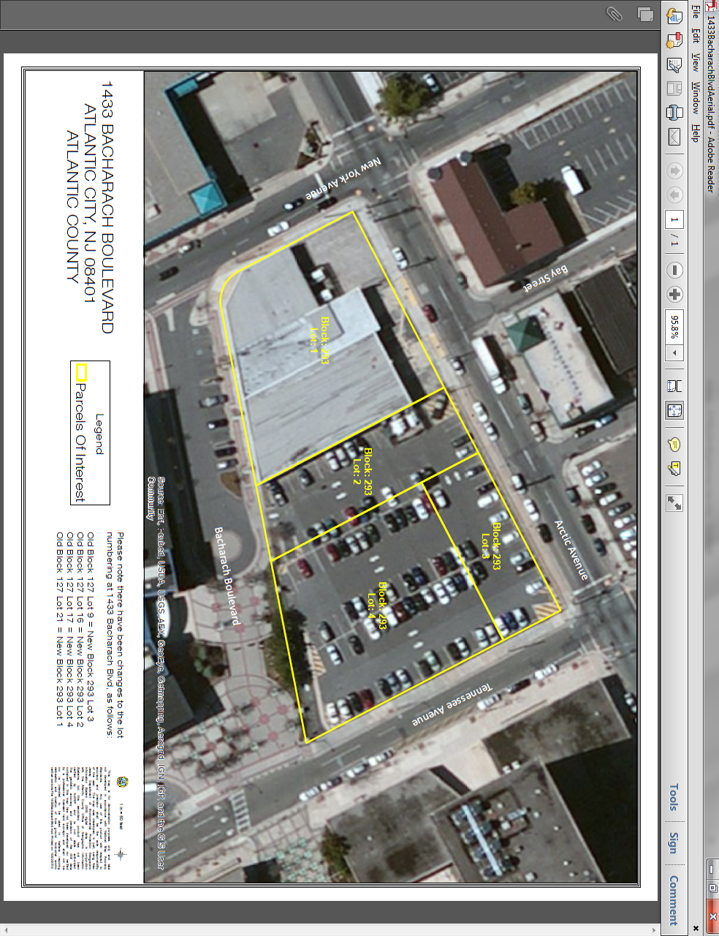
APPENDIX B: Environmental Remediation Specifications
- The Environmental Remediation Contractor shall submit a proposal for removal of all contaminate within the property limits. An immediate selection will be made once the bids are in and the winning bidder shall be notified the following Monday. Once a contractor is selected we are looking to move aggressively on starting. Please be prepared to start within a week once selected.
        - The proposed Environmental Remediation of contaminated materials must meet the approval of the NJDEP & our Environmental remediation Engineer for certification that all materials were successfully removed.
        - The work must be done as per the NJ State Department of Environmental Protection outlines as acceptable practice for removal of contaminated soils.
        - Removal of Underground Storage Tank/excavation and disposal of soil.

- Contractor to open existing and pump out 1000 fuel oil underground storage tank to inspect for contents. Should inspection determine residual fuel oil and/or any other liquids remaining in the UST, contractor to pump out and remove for disposal residual fuel oil and/or liquids. For bidding purposes, contractor to assume 1000 gallon of fuel oil and/or liquids to be removed for disposal. Contractor to ensure any liquids in piping to properly removed. Contractor to provide all bill of ladings/manifest to Owner for inspection.
Price for pump out and disposal of residual fuel oil and/or liquids $_________

- Contractor to excavate and dispose of 1000 fuel oil underground storage tank in accordance with all local, state and County regulations and laws. Contractor responsible for all local permits. Underground Storage Tank and all piping to be disposed at an appropriate recycling facility.
Price to excavate, remove and dispose of 1000 gallon fuel oil underground storage tank $_______

- Contractor excavate and dispose of soil around the underground storage tank. Soil to be disposed at an approved recycling facility selected by the contractor. Contractor to arrange for any pre-classification soil sampling, and provide Owner with results of the sampling, and acceptance letters by the selected disposal facility prior to excavation and disposal of soil. For bidding purposes, contractor may assume soil volume is 50 cubic yards. Contractor to provide to Owner a Certificate of Destruction/Certificate of Disposal upon completion of disposal.
Price to excavate and dispose of soil around underground storage tank $_________

- Contractor to provide, and install, adequate amount of CERTIFIED CLEAN FILL (with necessary documentation of certification) to Owner to replace excavated materials identified in item #3. Certification must meet requirements set forth in the “Alternative and Clean Fill Guidance for SRP Sites” Guidance document published by NJDEP dated December 29, 2011. For bidding purposes, contractor may assume 50 cubic yards of material to be provided and installed.*
Price to provide and install Certified Clean Fill $_________

- Note that material must also meet required engineering specifications.
- Imported structural fill, if required, should be a clean well-graded sand and gravel, free of all organic material and contaminates, with a maximum particle size of three (3) inches, between ten (10) and seventy (70) percent by weight passing the standard No. 40 sieve size and no more than twelve (12) percent passing the No. 200 standard sieve size. Suitability should be determined in accordance with ASTM D-422 Standard (Particle Size Analysis).
- Compact the structural fill in maximum loose lifts of ten (10) inches to at least ninety-five (95) percent of its maximum dry density as determined in the laboratory when tested in the laboratory in accordance with the ASTM D-1557 Standard.

A site visit may be necessary for your accuracy of this proposal. Please reach out to Steven Caputo Projects Operations Manager for setting up a walkthrough of the site. Cell: 609-364-3888

        - Availability to perform the job.
        - Lead time for turnaround results.

